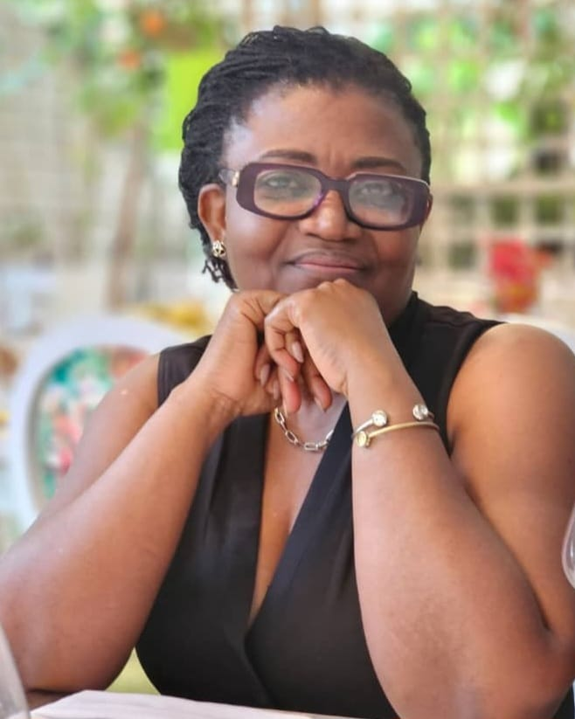
ING EVELYN GYAMPO
Environment Social Health and Safety Expert
BSc, MPhil, Cert, PE-GhIE.

Contacts
+233 20 052 4450

evegyampo@gmail.com

Tema, Greater Accra





Professional Overview

I am a Chemical Engineer and Environmental Management professional with over 20 years of experience in environmental and social sustainability, ESHS management and compliance, and stakeholder engagement. I have led environmental teams on major projects supported by national and international institutions, providing expertise in Environmental and Social Impact Assessment, environmental auditing, inclusive stakeholder consultation, and regulatory compliance. My work bridges technical environmental evaluation with governance, community engagement, and sustainability planning - often in collaboration with engineers, planners, and development institutions. These experiences reflect my continuing commitment to integrating ecological integrity, regulatory compliance, and social inclusion into infrastructure and climate-related projects.
Key Skills

- Project Facilitation, and Coordination
- Environmental & Social Impact Assessment (ESIA) Review and Oversight
- Inclusive Project Planning & Stakeholder Engagement
- Cleaner Production & Environmental Sustainability
- Project Negotiation, Public Consultation & Participation
- Project Monitoring, & Evaluation
- Public-Private Sector Collaboration

Education

Certificate in Climate Change, Sustainable Development and Clean Development Mechanisms Project Formulation, University of Twente – Netherlands (April 2008)

M.Phil. (Environmental Science) University of Ghana – Legon, Ghana (Dec 2006)

B.Sc. (Honours) Chemical Engineering - Kwame Nkrumah University of Science and Technology, Kumasi, Ghana (Nov 1993)

Employment

Lead Consultant (Environment Social Health and Safety)- Associated Consultants (Jan 2024 - Present
- Lead ESHS oversight, Compliance monitoring, quality assurance, and stakeholder engagement/coordination

Senior Consultant - Centre for Environmental and Health Research and Training (Nov 2023 - Jan 2024)
- Led environmental consultancy assignments -in assessment, compliance auditing, and stakeholder engagement.

Founding Partner - Aya Industries/ Katsa Technologies (Pty) Ltd. (Dec 2019 – Oct 2023)
- Entrepreneurship and business development in sustainable beverages, energy efficiency, and cleaner technologies

Certified Trainer for Inclusive EIA - UNDP/AfDB, Ethiopia, South Africa, Eswatini (Jun 2014 - Dec 2015)
- Review and Capacity development on integrating human rights, health, and gender into environmental assessment processes.
Environmental & Social Assessment Specialist – Millenium challenge Account Infrastructure Projects (Aug 2009 - Jun 2014)
- Led environmental and social assessment, management planning, stakeholder engagement, and sustainability inputs for major infrastructure projects.
Program Development Consultant Thusang Engineering Training and Consulting, South Africa (Feb 2009 – March 2010)
- Developed Environment, Health & Safety training programmes and institutional learning systems.
Environmental Consultant (Freelance) – Ghana (Aug 1998 - Jul 2008)
- Provided environmental consultancy services covering ESIA/EMP, cleaner production, capacity building, and CDM project development
Environmental Protection Agency - Ghana (1993 - 1996)
- Environmental assessment review, regulatory compliance, monitoring, stakeholder training, and chemical safety oversight.

Certifications

- Certified Trainer in Inclusive EIA Practices
- Member – Ghana Institution of Engineers
- Member - International Association of Impact Assessment
- Member - South African Institute of Chemical Engineers

Relevant Experience

Jan 2025 to date: Environment Social Health and Safety (ESHS) Expert - Accra Tema Motorway Construction
Collaborating with engineers and urban planners on the redesign and construction of Ghana’s main commercial corridor (the Accra–Tema Motorway) to enhance sustainability, climate resilience, and environmental performance. Engaging local governments, utility companies, and affected communities to facilitate utility relocation, safety initiatives, and resettlement processes, while monitoring labour conditions for compliance with ILO standards and supporting health and safety audits.
Aug 2024: Trainer - Climate Change Capacity Building for Technical Service Division, Ghana Audit Service
Designed and implemented a comprehensive capacity building program to enhance the skills of Ghana Audit Service staff in auditing Ghana's Climate Change Action Projects.
April 2024 - August 2025: Environmental and Social Frameworks Overview Assessment - Ghana, Liberia and Kenya
Assisted in the assessment that identified gaps between the World Bank’s Environmental and Social Framework (ESF) standards and national policy, legal, regulatory, and institutional frameworks.
Jan 2024: Ghana Landscape Restoration and Small-Scale Mining Project
Environmental & Social Management Inception Team Member of Ghana Landscape Restoration and Small-Scale Mining Project commissioned to develop the comprehensive Environmental and Social Commitment Plan (ESCP) that will align project activities with ecological and community priorities.
Inclusive Environmental Assessment Specialist Trainer - UNDP/AfDB
Designed and implemented a comprehensive training program focused on integrating health, gender, and human rights considerations into environmental impact assessments.
Environmental and Sanitation Specialist - Millennium Challenge Account (MCA) Ghana
Developed sustainable sanitation and water infrastructure standards for rural and school modernization programmes, and secured US$550,000 to deliver climate-resilient, culturally appropriate Biofil toilets across 11 districts.
Road Infrastructure Development Consultant - Ghana and Liberia
Conducted environmental evaluations, social impact analyses, and developed integrated management plans for transportation infrastructure projects financed by MCA and AfDB.
Industrial Cleaner Production and Compliance Expert - UNIDO Ghana
Established and implemented pollution prevention, eco-efficiency, and cleaner production programmes, including environmental performance audits and capacity building to support industries, manufacturers, and SMEs in meeting evolving compliance requirements.
EIA Project Lead - Ashesi University College Campus Development
Participated in directing impact assessment and developed an environmental management and sustainability framework integrating site planning, resource conservation, ecosystem protection, and community engagement for campus construction and operations.

